# Customer UI quick guide.

Table of Contents.

My Account 2

My Statistics 2

My Subscription 3

My Search 4

# My Account

This page contains information about a user account, and may look like below for new account, or have an additional column for requests.

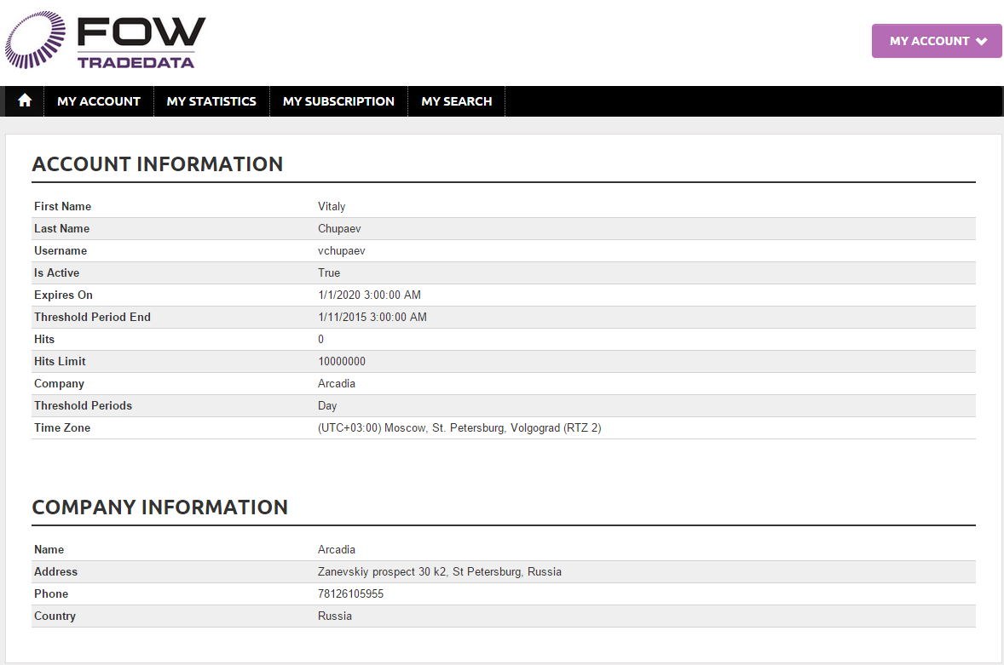

# My Statistics

This page shows the history of service calls for the account, including methods calls from any clients and search requests from the site.

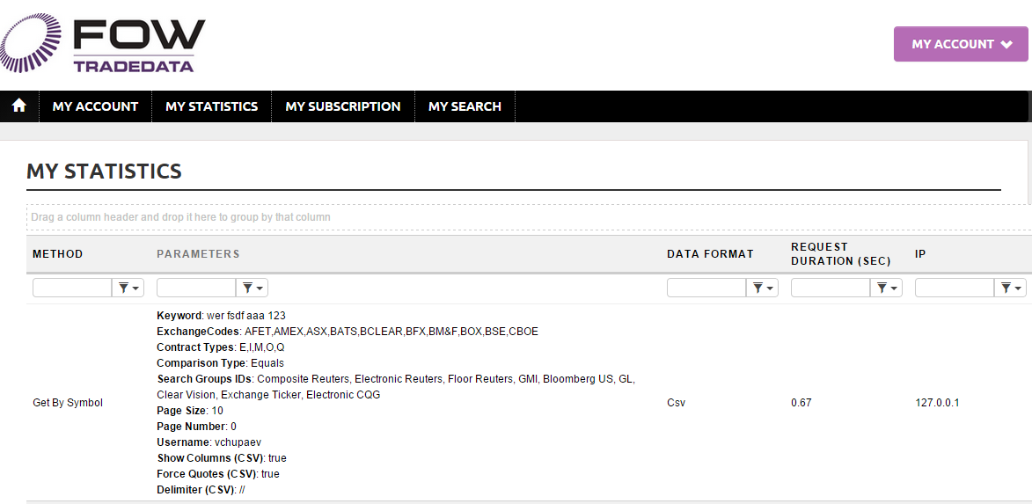

# My Subscription

This page allows to request administrator to subscribe for additional methods or unsubscribe from existing.

Subscribed packages are shown as checked,   
Requested packages are grayed out.  
Available for subscription like empty checkbox.

Packages marked as Free are not shown here.

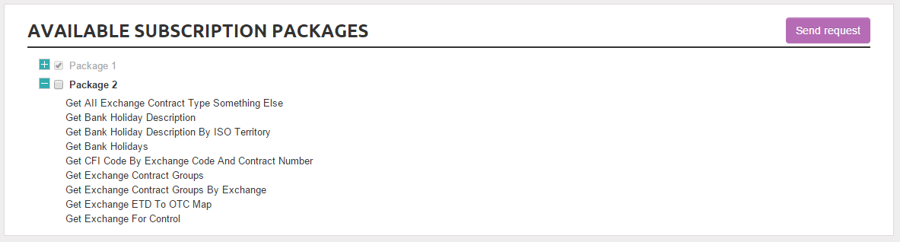

Once the request is sent user have to wait until it will be processed.

My Account page will now show additional information:  
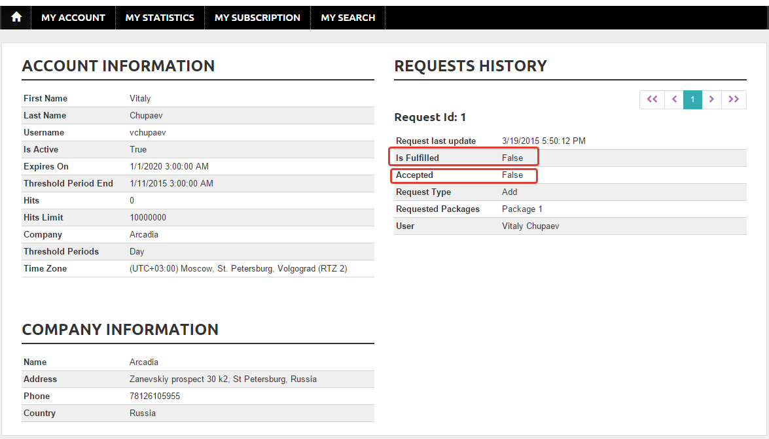

# My Search

This search page has more possibilities in comparison to search via the http requests.  
When search request is sent to the service via web client it is not possible to specify visible columns, all other options are the same.  
Search is done via the same method, but when using site this method is called directly and provides more options.

User can save his query at any point – before search or after it.  
When loading saved query, its name also will be loaded:

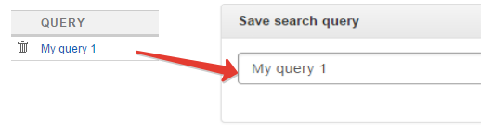

When saving again, the query with the same name will be updated, otherwise a new one created.

Export is equivalent to search, but has no paging, it tries to load all requested data, so be careful - it may contain hundreds of megabytes of data.

Service Configurations table in Admin UI contains a group of settings for export:

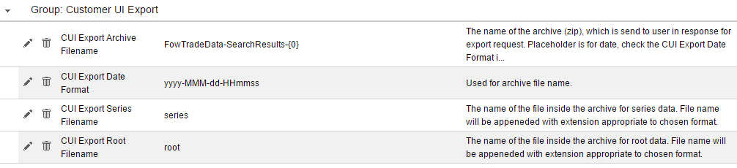

Export data is zipped and then archive is sent to user.

File names look like this:

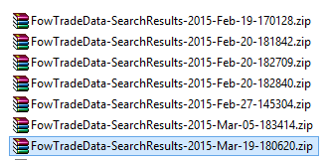

And inside of the archive:

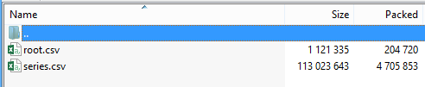

One trick, may be not known for users, is how to deselect the last item in the list:

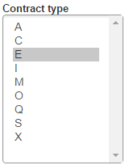

Keep the **CTRL** key pressed down and **click** on the item.